Neural Network and Deep Learning
Neural networks, also known as artificial neural networks (ANNs) or simulated neural networks (SNNs), are a subset of machine learning and are at the heart of deep learning algorithms. Their name and structure are inspired by the human brain, mimicking the way that biological neurons signal to one another.
- Neural networks are a series of algorithms that mimic the operations of an animal brain to recognize relationships between vast amounts of data.
- Neural networks with several process layers are known as "deep" networks and are used for deep learning algorithms
- Neural networks can help computers make intelligent decisions with limited human assistance. This is because they can learn and model the relationships between input and output data that are nonlinear and complex.
They are used in a variety of applications in financial services, from forecasting and marketing research to fraud detection and risk assessment.
A Neural Network arranges algorithms in such a way that it can make reliable decisions on its own, whereas a ML Model makes decisions based on what it has learnt from the data. As a result, while Machine Learning models may learn from data, they may need some human interaction in the early stages.

Neural Networks have the ability to learn by themselves and produce the output that is not limited to the input provided to them. The input is stored in its own networks instead of a database, hence the loss of data does not affect its working.
Deep learning is an important element of data science, which includes statistics and predictive modeling. It is extremely beneficial to data scientists who are tasked with collecting, analyzing and interpreting large amounts of data; deep learning makes this process faster and easier.

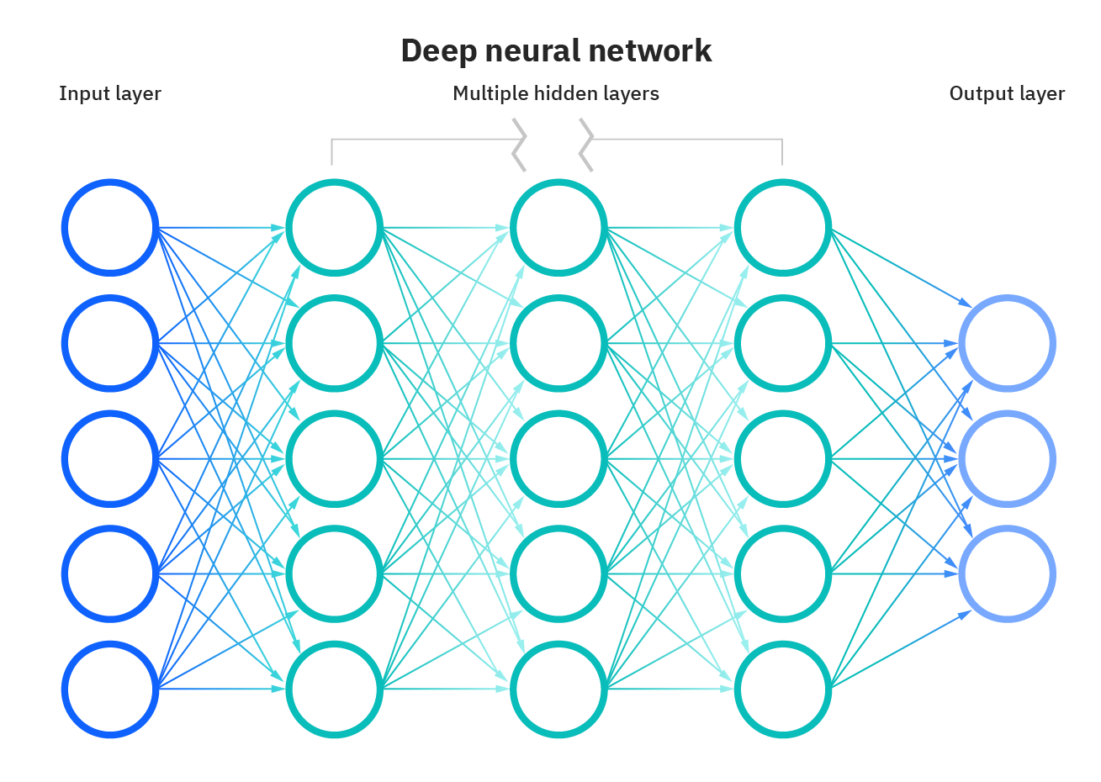

Different types of Neural Networks in Deep Learning
- Artificial Neural Networks (ANN)
- Convolution Neural Networks (CNN)
- Recurrent Neural Networks (RNN)

Artificial Neural Network (ANN) – A single perceptron (or neuron) can be imagined as a Logistic Regression. Artificial Neural Network, or ANN, is a group of multiple perceptrons/ neurons at each layer. ANN is also known as a Feed-Forward Neural network because inputs are processed only in the forward direction

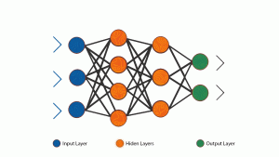
As you can see here, ANN consists of 3 layers – Input, Hidden and Output. The input layer accepts the inputs, the hidden layer processes the inputs, and the output layer produces the result. Essentially, each layer tries to learn certain weights.
ANN can be used to solve problems related to
- Tabular data
- Image data
- Text data

Recurrent Neural Network (RNN) A looping constraint on the hidden layer of ANN turns to RNN.
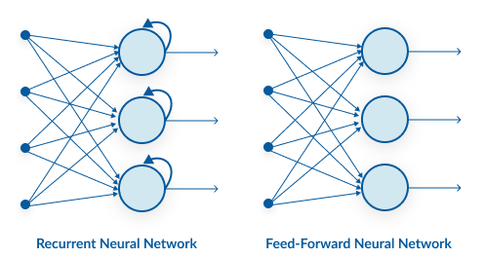
As you can see here, RNN has a recurrent connection on the hidden state. This looping constraint ensures that sequential information is captured in the input data.
We can use recurrent neural networks to solve the problems related to:
- Time Series data
- Text data
- Audio data
Convolutional Neural Networks
Convolutional neural networks, also called ConvNets or CNNs, have several layers in which data is sorted into categories. These networks have an input layer, an output layer, and a hidden multitude of convolutional layers in between. The layers create feature maps that record areas of an image that are broken down further until they generate valuable outputs. These layers can be pooled or entirely connected, and these networks are especially beneficial for image recognition applications.
The building blocks of CNNs are filters or kernels. Kernels are used to extract the relevant features from the input using the convolution operation. Let’s try to grasp the importance of filters using images as input data. Convolving an image with filters results in a feature map
CNN captures the spatial features from an image. Spatial features refer to the arrangement of pixels and the relationship between them in an image. They help us in identifying the object accurately, the location of an object, as well as its relation with other objects in an image
CNN also follows the concept of parameter sharing. A single filter is applied across different parts of an input to produce a feature map.

References
https://www.investopedia.com/terms/n/neuralnetwork.asp#:~:text=A%20neural%20network%20is%20a,organic%20or%20artificial%20in%20nature.
https://www.ibm.com/in-en/cloud/learn/neural-networks
https://www.analyticsvidhya.com/blog/2020/02/cnn-vs-rnn-vs-mlp-analyzing-3-types-of-neural-networks-in-deep-learning/

